RETAIL SALES PERFORMANCE ANALYSIS
WEEK 6 – PROJECT REPORT
Name: KEVIDYA T E
Roll No.: E25FA055
Microsoft Power BI Desktop

1. Introduction
This report explains the Retail Sales Performance dashboard created in Microsoft Power BI. The dashboard presents the organisation's sales, profit, orders and quantity, and helps users understand performance across product categories, store types, cities and stores. It also provides slicers to view the results for selected years, states, store types, customer segments and product categories.
2. Objectives
To display the overall sales performance through key performance indicators (KPIs).
To compare revenue and profit across different product categories.
To understand how revenue is distributed among different store types.
To compare revenue across cities and individual stores.
To allow users to filter the dashboard by year, state, store type, customer segment and product category.
3. Dataset Description
The screenshots show a retail sales dataset containing information used to analyse revenue, cost, profit, orders and quantity. The dashboard also uses fields for year, state, store type, customer segment, product category, city and store name. The screenshots do not show the full source-table names or complete column list, so this report describes only the fields visible in the dashboard.
Field / Category | Visible information | Purpose in analysis
Sales measures | Revenue, cost, profit, orders, quantity | Summarise overall business performance.
Product details | Accessories, Audio, Home Appliances, Laptops, Mobile Phones, Televisions, Wearables | Compare performance by product category.
Store details | Flagship, Mall, Online, Suburban, Urban; store name and city | Compare revenue by store type, city and store.
Customer and location details | Customer segment and state | Filter results for different customer groups and locations.
Time details | Year (2024–2026) | Review performance across the selected period.

4. Tools Used
Microsoft Power BI Desktop for creating the report and dashboard visuals.
Power Query / data preparation features for preparing the dataset (where applicable).
Power BI visualisations, cards, slicers and filters for presenting and exploring the data.
5. Dashboard Overview
The dashboard contains KPI cards at the top, charts in the main area and slicers for interactive filtering. The visuals present revenue by product category, revenue distribution by store type, revenue trends over time, revenue by city, revenue by store and store-level performance details. 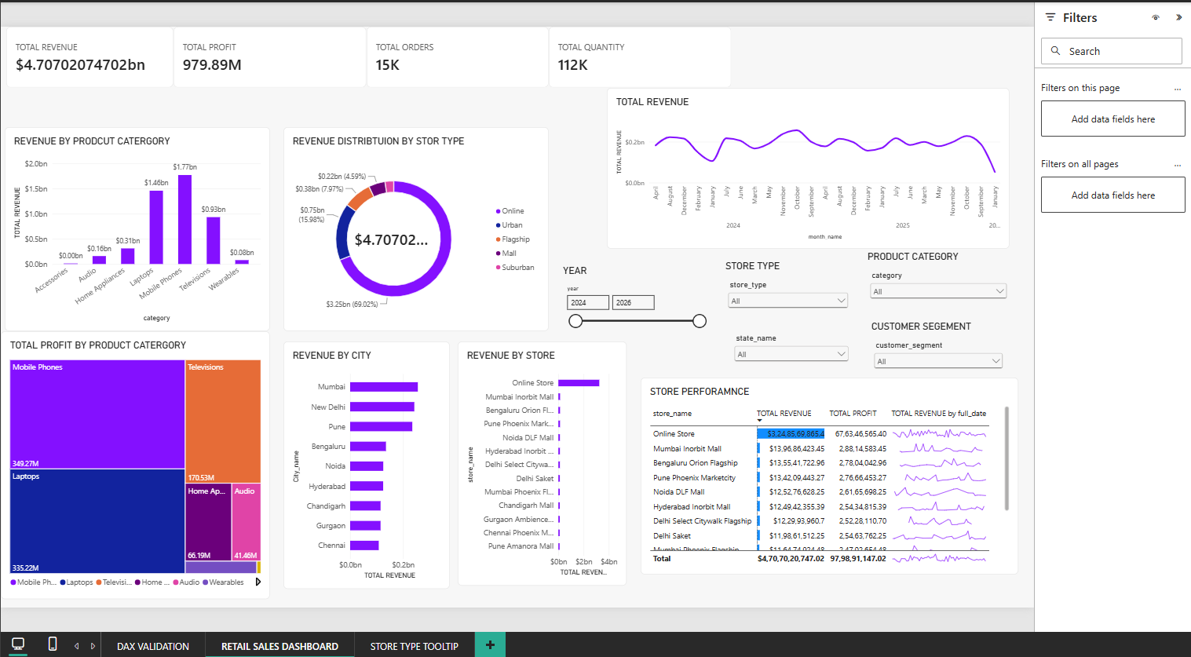
Figure 1: Retail Sales Performance dashboard
6. Key Performance Indicators (KPIs)
The KPI cards provide a quick summary of the business performance. The main dashboard displays total revenue, total profit, total orders and total quantity.
KPI | Value shown | Meaning
Total Revenue | $4.70702074702bn (approximately $4.71bn) | The total sales revenue recorded in the dataset.
Total Profit | 979.89M | The profit earned from the sales.
Total Orders | 15K | The total number of orders.
Total Quantity | 112K | The total quantity of products sold.
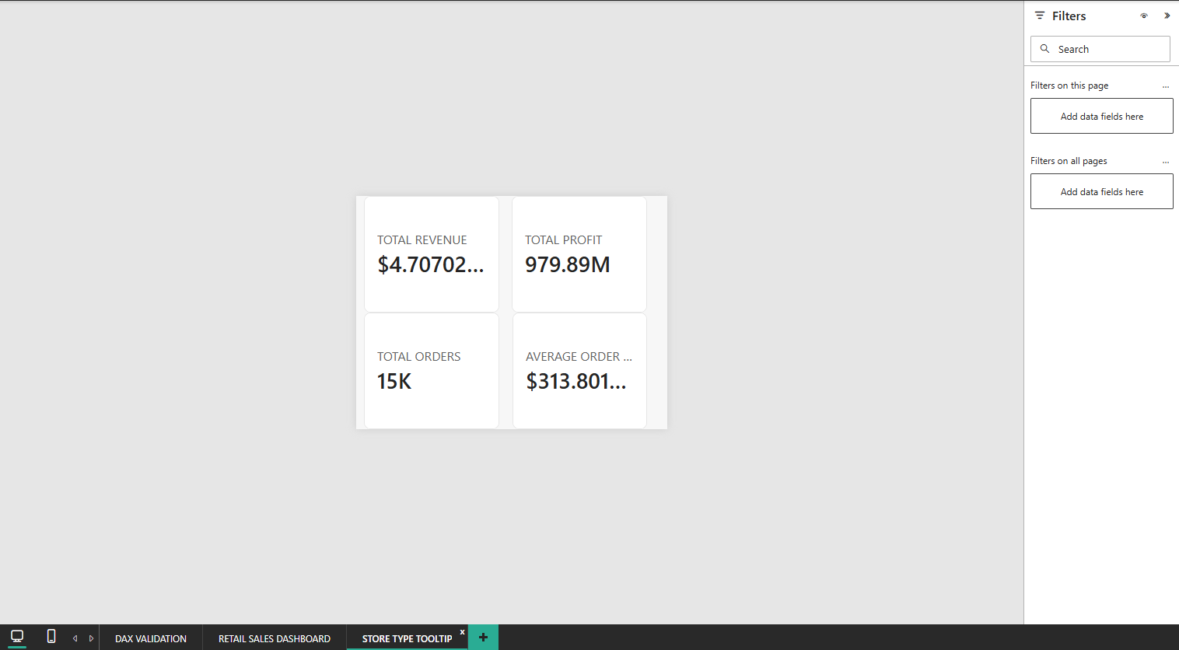
Figure 2: KPI tooltip page showing revenue, profit, orders and average order value
7. Visualisations Used
7.1 Revenue by Product Category
A column chart compares revenue across product categories. Mobile Phones and Laptops have the highest revenue in the chart, followed by Televisions. Home Appliances and Audio contribute smaller amounts, while Accessories and Wearables show comparatively low revenue. This visual helps identify the product categories that contribute most to total revenue.
7.2 Revenue Distribution by Store Type
A donut chart shows how total revenue is shared among the store types. Online stores contribute the largest share (about 69.02%), followed by Urban stores (about 15.98%), Flagship stores (about 7.97%) and Mall stores (about 4.59%). Suburban stores make up the remaining share shown in the chart. This visual helps compare the contribution of each store type.
7.3 Total Revenue
A line chart displays total revenue across months and years. It helps users observe changes in revenue over time, identify higher and lower periods, and understand the overall revenue trend.

7.4 Total Profit by Product Category
A tree map compares total profit across product categories. The size of each section represents the profit contributed by that category. Mobile Phones and Laptops occupy the largest areas, showing their major contribution to profit in the displayed chart.
7.5 Revenue by City
A horizontal bar chart compares revenue across cities, including Mumbai, New Delhi, Pune, Bengaluru, Noida, Hyderabad, Chandigarh, Gurgaon and Chennai. It helps identify the cities with higher revenue.
7.6 Revenue by Store
A horizontal bar chart compares revenue generated by individual stores. It helps identify the stores that contribute more revenue and compare their performance.
7.7 Store Performance
A table presents store-level details, including store name, total revenue, total profit and a revenue trend sparkline. It allows users to compare individual store performance in one place.
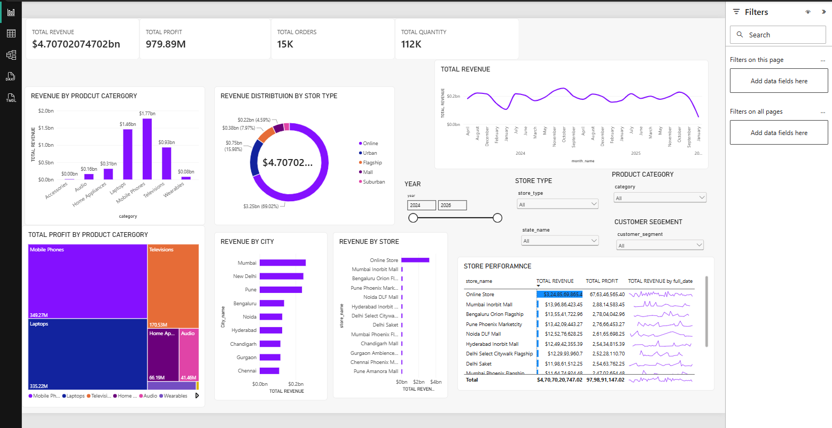
Figure 3: Main dashboard with category, store type, city, store and trend analysis
8. Slicers and Filters Used
The dashboard includes slicers that allow users to select specific data and update the visuals accordingly. The visible slicers are:
Year – selects the period, with 2024 to 2026 shown.
State – filters results by state, such as Tamil Nadu, Karnataka, Delhi and others.
Store Type – filters by Flagship, Mall, Online, Suburban or Urban.
Customer Segment – filters by Premium, Occasional, Regular or Value.
Product Category – filters by Accessories, Audio, Home Appliances, Laptops, Mobile Phones, Televisions or Wearables.
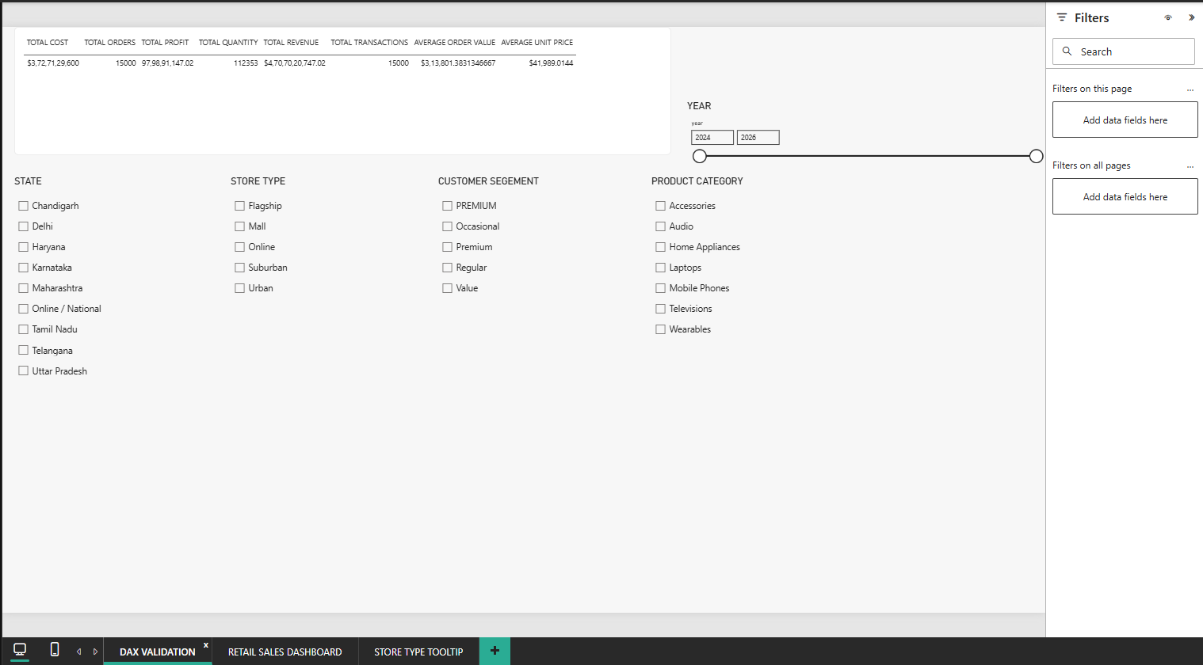Figure 4: Slicer and filter selection page
When a user selects a year, state, store type, customer segment or product category, the dashboard visuals are filtered to show the matching results. This makes it easier to study a particular part of the business.
9. Key Insights
The dashboard records 15K orders and approximately 112K units of quantity.
Total revenue is approximately $4.71bn in the KPI display, and total profit is 979.89M.
Mobile Phones and Laptops are the leading product categories by revenue in the category chart.
Online stores contribute the largest share of revenue, at about 69.02%.
The dashboard compares revenue across several cities and individual stores, helping identify stronger-performing locations.
The year, state, store type, customer segment and product category slicers allow users to explore the results in detail.

10. Conclusion
The Retail Sales Performance dashboard converts the sales dataset into an easy-to-understand visual report. The KPI cards summarise revenue, profit, orders and quantity, while the charts explain performance by product category, store type, city and store. The slicers make the report interactive and allow users to focus on selected years, locations, customer segments and product categories. Overall, the dashboard supports better understanding of sales performance and helps identify important areas of the business.

